Gloria Pappalardo and Jess Strzempko

Conservation International Report

GEOG 382 Advanced Remote Sensing

06.04.2021

Assessment of Factors Related to Conservation of Indigenous People & Local Communities’ Land in Parque do Xingu, Mato Grosso, Brasil

Research Question

This project seeks to answer the question of how the establishment of legal land titles for Indigenous Peoples and Local Communities (IPLC) has impacted conservation efforts. Additionally, how does the population growth, enviro-climatic trends, landscape change, and increased accessibility within and around IPLC land impact conservation efforts? We structure our analysis based on the framework of impact evaluation through the sourcing of key climatic and anthropogenic factors from an IPLC site and a corresponding counterfactual control site (Ferraro, 2009). We further incorporate qualitative information regarding the creation of protected areas by the Brazilian government and the organization of forest restoration efforts by Conservation International (CI) and their partners into the impact assessment.

Background

Throughout the Legal Amazon, CI is implementing a project entitled *Impact Evaluation for Natural Climate Solutions* (NCS). NCS includes actions to protect existing unused land and resources, sustainably manage land currently in use, and restore land used in the past to healthy conditions (Griscom et al., 2017). Restoration projects supported by CI vary in approach, but ultimately aim to reforest land that was formerly deforested for agricultural or commercial reasons. Methods used by CI and their collaborators include natural regeneration, nucleation, seedling plantation, agroforestry systems, direct seeding, and tropical silviculture. The placement of restoration sites on protected, indigenous land serves the twofold purpose of potentially increasing the chance of successful forest regeneration while restoring forest managed by stewards of the land.

Project Objectives

The principal goal of this project is to determine the efficacy of titling IPLC sites as a method of improved conservation of intact forest and associated ecosystem services as compared to adjacent non-IPLC land with similar environmental characteristics. We address this question through the selection and analysis of a case study IPLC site on protected land in which Conservation International is engaged in forest restoration.

In this case study, we source socio-environmental information relevant to deforestation in the selected site and counterfactual buffer zone. We aim to be cognizant of spatial spillover effects of deforestation that arise from road construction in adjacent land parcels (Pfaff et al., 2007). We gather the information necessary to perform matched pair tests to determine significant differences between chosen IPLC sites and their counterfactual zones (Blackman, 2013). We present this information in both a summary and visual format through the respective calculation of variable statistics and the creation of maps depicting spatial patterns. We further use high-resolution imagery to visually examine areas of interest, primarily deforested land adjacent to restoration sites. Our final objective is to provide a report of the project’s findings to CI to advise the management of their conservation work in the Brazilian Amazon.

We hypothesize that the chosen IPLC site will demonstrate lower rates of deforestation for the 2000-2019 time frame than the counterfactual buffer zone as a result of the existence of legal land titles for the region. The unique characteristics of each IPLC site engenders distinctive conservation challenges and successes. Furthermore, the titling of IPLC land is only as effective to conservation as the governmental or community enforcement of property rights and autonomy. We study the contextual evidence for the chosen IPLC site to gain an understanding of the singular circumstances of the location. We theorize that factors of accessibility, e.g., proximity to roads and major towns, will correlate to higher rates of deforestation, while the factors that promote land stewardship and forest recovery, e.g., the presence of restoration work, will correlate to the opposite.

Study Area

The area chosen for the study is the protected land of Parque do Xingu (Xingu Indigenous Park) as well as three of the adjacent indigenous lands – Batovi, Wawi, and Pequizal do Naruvôtu. Parque do Xingu is the oldest of the four lands, having been decreed an “Indigenous Park” in 1961 by the Brazilian president after a political struggle with the government of Mato Grosso, the state within which it resides (Menezes, 2009). While the purpose of Parque do Xingu is to protect the environment and the indigenous people, deforestation and pollution just outside the perimeter of the park has remained a threat. Contact was established with the people of the Wawi and Batovi indigenous lands in 1997 with official land decrees approved in 1998. The people of Pequizal do Naruvôtu were contacted early in the 21st century and received an official land decree in 2016 (Instituto Socioambiental, 2021).

Parque do Xingu and the adjacent lands constitute a contiguous section of protected land with a complicated history. This area was chosen for the study as it contains the highest number of Conservation International restoration sites out of all the protected IPLC lands containing restoration work in the Legal Amazon. The primary method of restoration in the focus area is direct seeding with several other sites using agroforestry systems and seedling plantations. See Figure 1 below for a map of where these lands are in relation to the Legal Amazon and the distribution of restoration sites within it.

Boundary information about IPLC land is collected by CI in 49 countries worldwide, with 8 in the Legal Amazon. The information provided by CI included an indication of tenure rights and property regimes based on Elinor Ostrom's seminal work studying the management of shared environmental resources (Ostrom, 1990). IPLC site establishment through legal measures is dependent on the desires of the local indigenous community and the political will of the national government (Plant & Hvalkof, 2001). The process can take years and require a substantial investment of time and money.

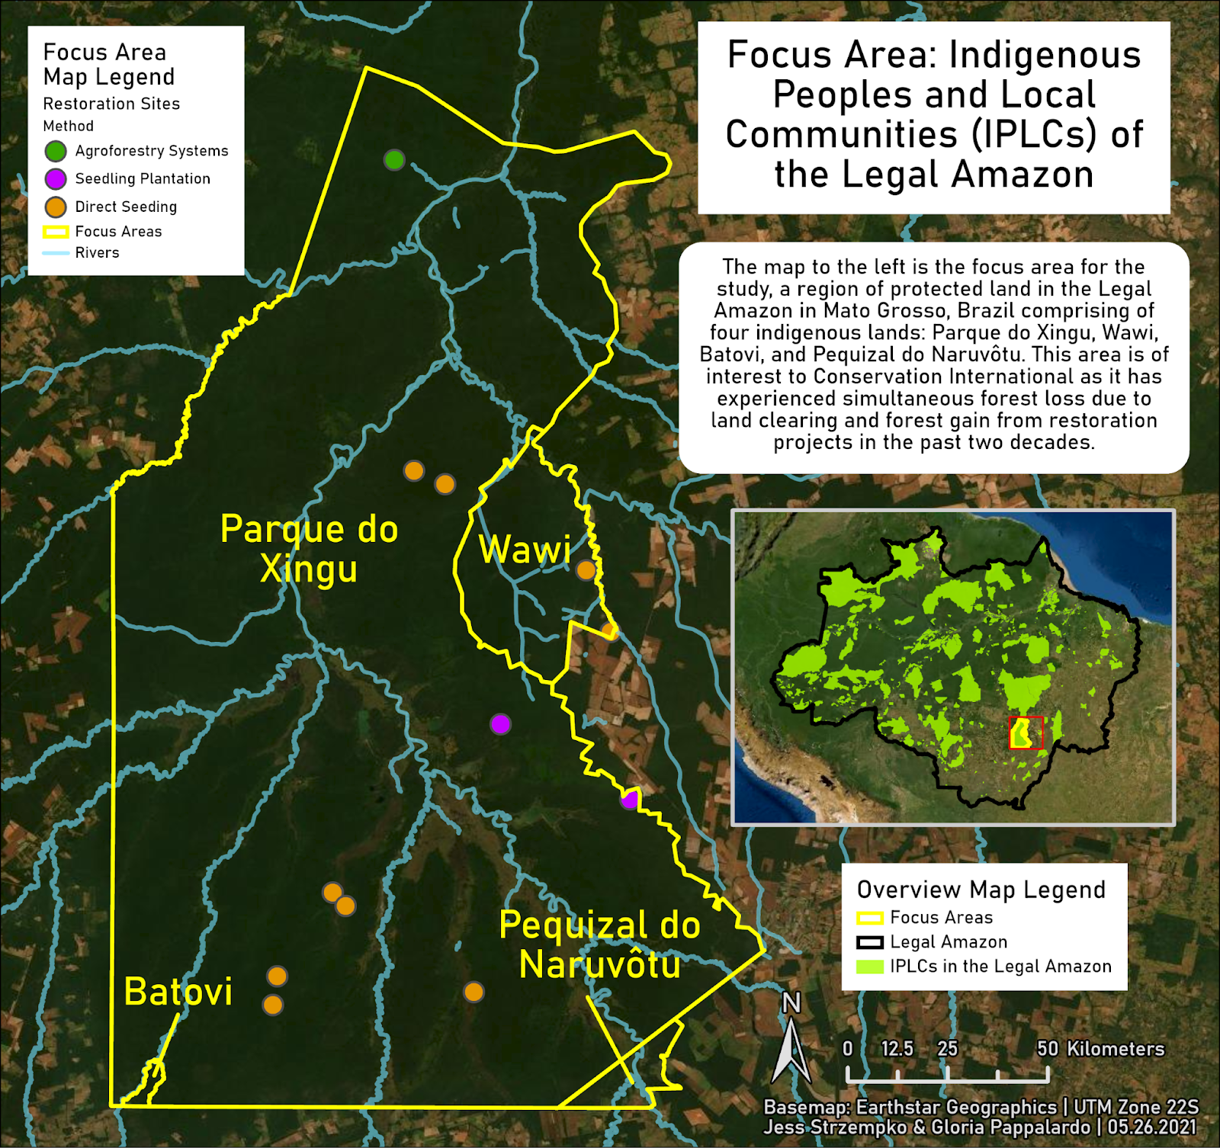

**Figure 1.** Map of Parque do Xingu, Wawi, Batovi, and Pequizal do Naruvôtu indigenous lands selected as the study area for analysis with location of restoration sites.

Scene Model

See Table 1 below for a scene model of the project. A scene model is a framework used in remote sensing research to rectify the discrepancy between the scene, the real-life study area, and the image, as well as plan the needed spatial information and measurements derived from the scene (Strahler et al., 1986). The scene model is used by remote sensing scientists to parameterize the scene for analysis.

**Table 1.** Scene model specifications for a data set to determine significant social and environmental impacts of IPLC existence.

|  |  |
| --- | --- |
| Information required | Canopy height, forest loss, proximity to roads, proximity to towns, fire events, elevation, slope, precipitation, population, restoration sites, protected areas, IPLC status |
| Spatial scale | Grain = IPLC land and restoration sites  Extent = Legal Amazon, selected IPLC land/protected area |
| Temporal scale | 2000-2020 |
| Environment type | Rainforest in the Legal Amazon  Developed commercial and agricultural land |
| Components and hierarchy | Constraint = Legal Amazon  Focus = IPLC site  Mechanism = tree stands, fires, roads, rivers, towns, population centers |
| Spatial dimensions | H-resolution (varies from 30 m2 for forest and elevationto 1 km2 for MODIS fire product and about 5.55 km2 for precipitation )  Grain = 15-5500 m²  Extent = 45,970 km² |
| Temporal dimensions | Time Interval = 2000-2019 or 2020  Optimal date = annual data collection in summer  Solar conditions = 0°–20° zenith angles  (11:30 – 2 hours) (12:30 + 2 hours)  Minimize shadows from canopy elements |

|  |  |
| --- | --- |
| Spectral dimensions | Landsat 8:  Blue 0.45-0.51 µm  Green 0.53-0.59 µm  Red 0.64-0.67 µm  Near Infrared (NIR) 0.85-0.88 µm  SWIR 1 1.57-1.65 µm  SWIR 2 2.11-2.29 µm  MODIS (wavelength listed at each band’s center):  Channel 1 0.65 µm  Channel 2 0.86 µm  Channel 7 2.1 µm  Channel 21 4 µm  Channel 22 4 µm  Channel 31 11 µm  Channel 32 12 µm (Giglio et al, 2016) |
| Radiometric dimensions | Grain (quantization): 0.01 (reflectance)  Extent (dynamic range): up to 12 bits |
| Error tolerance levels | Correlation coefficients ≥ 0.5, R² ≥ 0.10  Biophysically reasonable estimations of forest cover in output (e.g., no forest cover in bodies of water)  Note: restoration sites were georeferenced and digitized from a static map. |

Data Description

1. Legal Amazon & IPLC Boundaries
   1. Provided by Sushma Shrestha of Conservation International
   2. The layer is a polygon of Brazil’s Legal Amazon (BLA), as defined by CI. BLA, established in 1948, is one of three socio-geographic divisions in Brazil. There are additional polygons of IPLC sites identified and mapped by CI.
2. Forest Loss & Canopy Height
   1. [Source](https://earthenginepartners.appspot.com/science-2013-global-forest/download_v1.7.html) & [Source](https://glad.earthengine.app/view/global-forest-canopy-height-2019) (University of Maryland Global Forest Change 2000-2019)
   2. The results from a time-series analysis of Landsat images in characterizing global forest extent and change from 2000 to 2019. One layer contains the extent of forest loss at a 30 m resolution per year, while the other contains canopy height in 2019 in meters.
3. Roads
   1. [Source](https://www.globio.info/download-grip-dataset) (Globio Global Roads Inventory Project)
   2. A dataset of global roads for use in environment and biodiversity assessments. Other datasets we considered include [Amazonia Ambiental Roads](https://www.amazoniasocioambiental.org/en/maps/#download) and [NASA Socioeconomic Data and Application Center](https://sedac.ciesin.columbia.edu/data/set/groads-global-roads-open-access-v1#:~:text=Additional%20Information-,Global%20Roads%20Open%20Access%20Data%20Set%20(%20gROADS,%2C%20v1%20(1980%20%E2%80%93%202010)&text=Purpose:,the%20extent%20possible%2C%20topologically%20integrated). The chosen dataset was selected as it appeared to contain the most detailed and recent information.
4. Major towns and settlements
   1. [Source](https://www.ibge.gov.br/geociencias/organizacao-do-territorio/estrutura-territorial/27385-localidades.html?=&t=downloads) (Instituto Brasileiro de Geografia e Estatistica)
   2. A point dataset of major town and village centers. The layer contain information about whether or not a settlement is urban or rural.
5. DEM
   1. [Source](https://drive.google.com/drive/folders/1MhGVFUFKPhjW-GiMSv5CgReK9L8OfUpy?usp=sharing) (Advanced Spaceborne Thermal Emission and Reflection Radiometer Global Digital Elevation Model)
   2. Digital Elevation Model at 30 m resolution and covers 99% of the Earth’s landmass.
6. Slope
   1. Derived from DEM
   2. Slope is the rate of change of elevation for each DEM cell and is calculated through a simple rise-over-run computation.
7. Precipitation
   1. [Source](https://developers.google.com/earth-engine/datasets/catalog/UCSB-CHG_CHIRPS_DAILY) (Climate Hazards Group InfraRed Precipitation with Station Data)
   2. CHIRPS data incorporates 0.05° resolution satellite imagery (approximately 5.55 km at the equator) with in-situ station data to create gridded rainfall time series for 1981-2021.
8. Fires
   1. [Source](https://firms.modaps.eosdis.nasa.gov/active_fire/#firms-shapefile) (NASA Fire Information for Resource Management System)
   2. NASA FIRMS is near-real time active fire data from Moderate Resolution Imaging Spectroradiometer (MODIS) Collection 6 aboard the Terra and Aqua satellites. The layer is point data of detected fires for 2000-2020.
9. Restoration sites
   1. Provided by Carlos Muñoz Brenes of Conservation International.
   2. Locations where Conservation International is partnering with groups like the Priceless Planet Coalition to perform forest restoration work. Six different methods of restoration are employed at the sites. Data is a static map sent as a png image file.
10. Protected Areas
    1. [Source](https://www.protectedplanet.net/country/BRA) (World Database on Protected Areas)
    2. The layer contains polygons of protected areas courtesy of Protected Planet. The data is updated monthly with submissions from governments, non-governmental organizations, landowners, and communities.
11. Population
    1. [Source](https://www.worldpop.org/geodata/summary?id=49732) (WorldPop)
    2. Estimated total number of people per 3 arc seconds grid cell (approximately 100 m at the equator). Layer is in geotiff format with units of number of people per 100 m by 100 m pixel.
12. Hydrography
    1. [Source](https://data.humdata.org/dataset/hotosm_bra_west_waterways) (HOTOSM waterways)
    2. Humanitarian OpenStreetMap export of West Brazil waterways as lines with features describing type, width, and name per segment of the waterway. Updated three months ago and downloaded from the Humanitarian Data Exchange (HDX).

Methodology

The methodology of the project is presented in Figure 2. The diagram presents from left to right, beginning with pre-processing steps before moving to analysis, visualization, and summarization of results. The process of site selection is shown across the top of the diagram. In these steps, general locations of restoration work were coupled with spatial information about the status of protected and indigenous lands in the Legal Amazon to select an appropriate site for analysis. The site of Parque do Xingu and the adjacent indigenous lands were primarily chosen due to the high number of restoration sites in the area. Other sites in consideration included the Araribóia and Koatinemo indigenous lands. A 20 km buffer was then created around the site in order to compare the results for each variable of interest.

The bottom half of the diagram demonstrates how the variables were each analyzed upon site selection. Variables were split into four main areas of concern: accessibility measures, population growth, enviro-climatic trends, and landscape change. Information pertinent to each area of concern was summarized in graphs and visualized with corresponding maps. Distance analyses were conducted using the rivers, roads, and towns data. Only major rivers, as opposed to streams and other smaller tributaries, were selected from the OpenStreetMap (OSM) data for the analysis to provide an equivalent level of travel as on roads. Additionally, smaller streams were not fully mapped in the OSM data for the entire study area. Raster for distance analysis were created in TerrSet using the 30-meter forest loss product as a template. All other variables were summarized according to the raw values of the data. The zonal statistics tool in ArcPro was used to determine average annual values of population and precipitation. The presence and location of restoration sites was considered in the individual and combined analyses of variables to consider potential temporal and spatial trends.

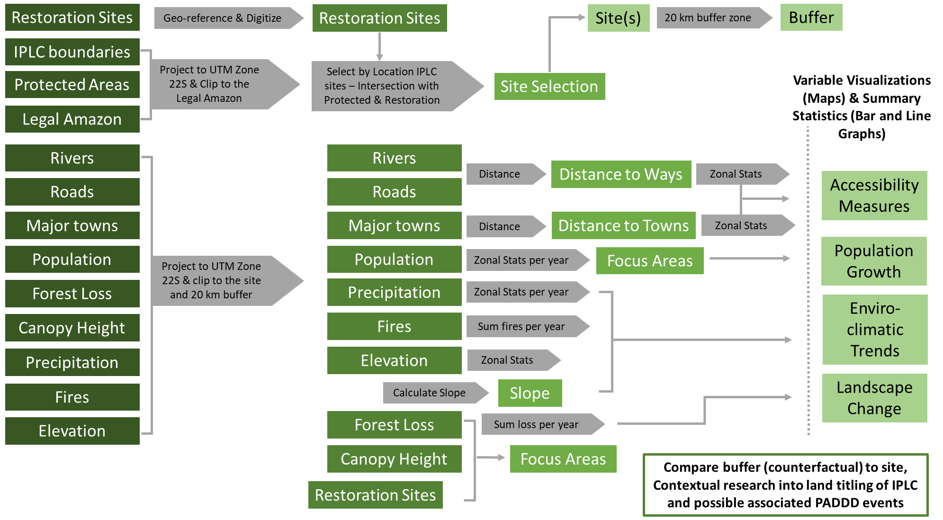

**Figure 2.** Methodology of geoprocessing and spatial analysis performed for the CI IPLC project.

Results

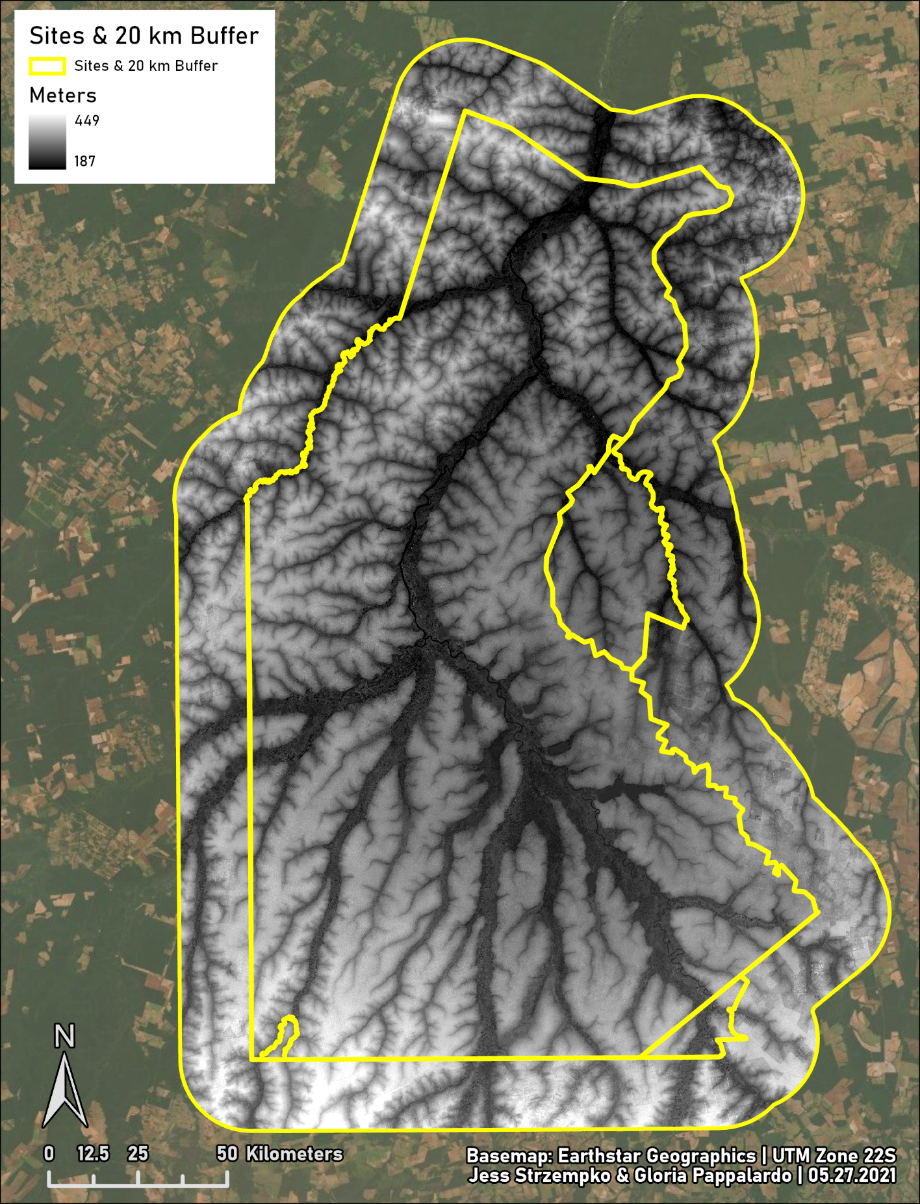

**Figure 3.** Lower elevation values are found in the river valley that intersects the center of the study area.

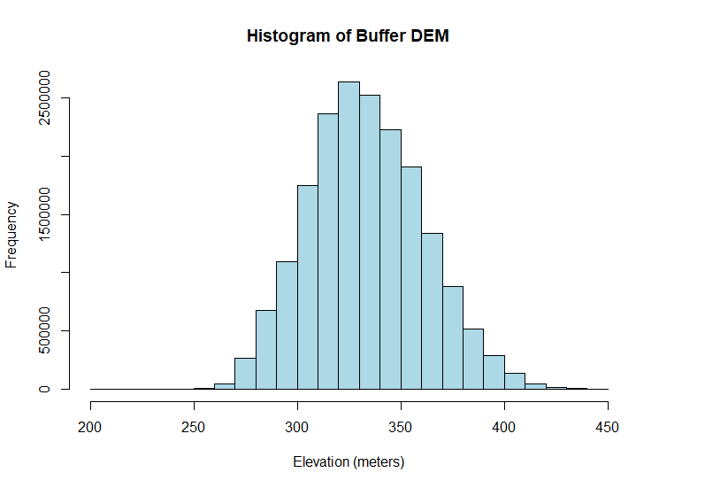**Figure 4.** Histogram of elevation variability for the buffer.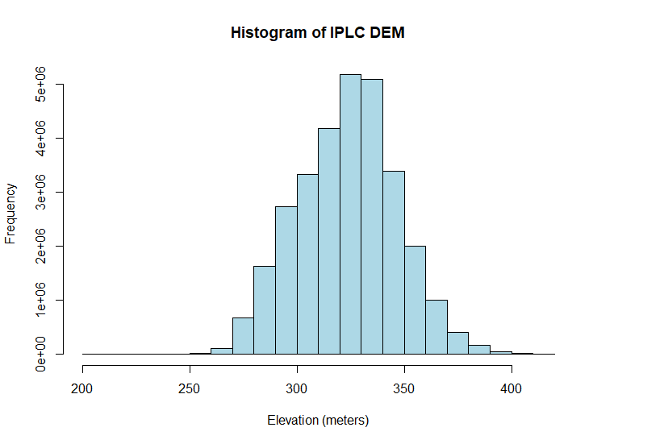

**Figure 5.** Histogram of elevation variability for the site. The elevation of the site and the buffer both have geometric medians of about 325 meters, with a range of values between 187 and 449 meters.

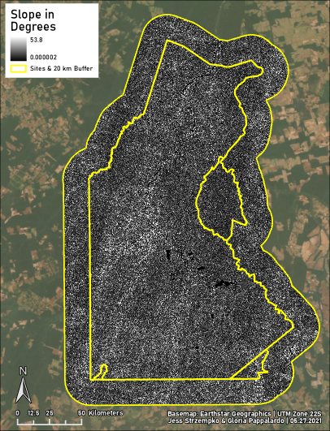

**Figure 6.** Slope in degrees is derived from the digital elevation model data. The area with the highest slope is found to the west of the Xingu River

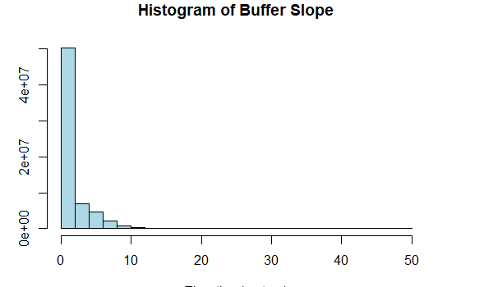

**Figure 7.** Histogram of slope variability for the buffer**.**

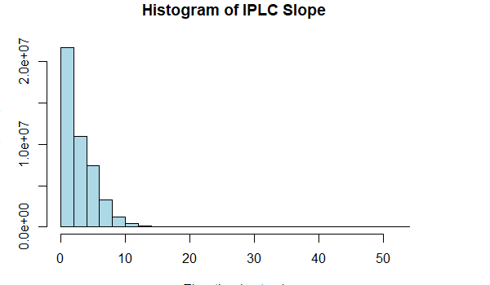

**Figure 8.** Histogram of slope variability for the site. The site and the buffer have similar slope distributions.

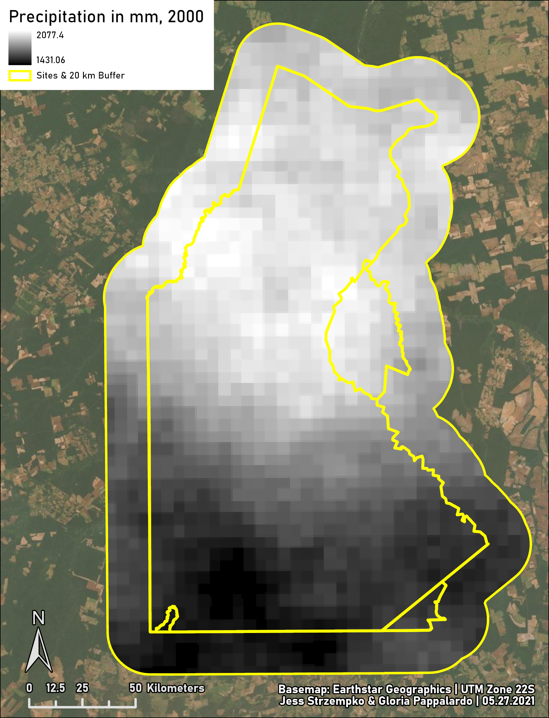

**Figure 9.** Map of total precipitation per pixel in 2000.

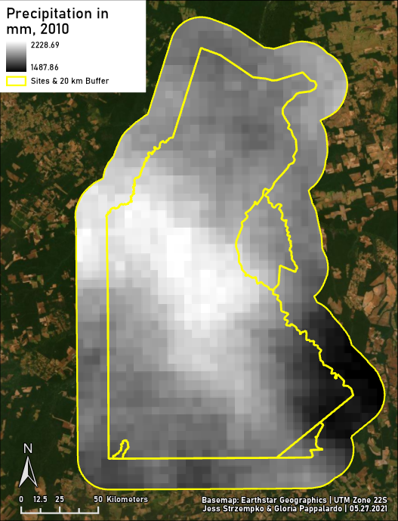

**Figure 10.** Map of total precipitation per pixel in 2010.

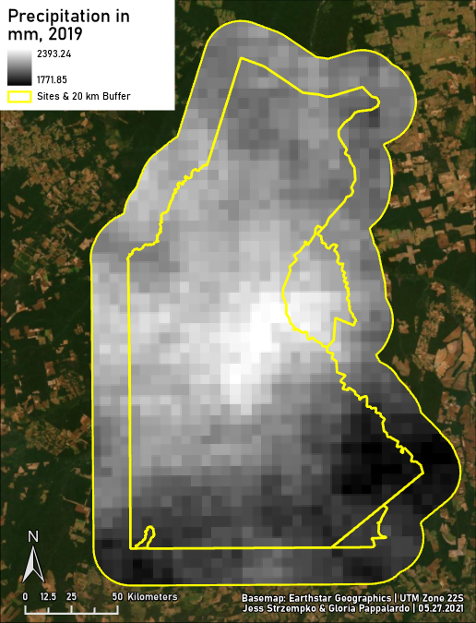

**Figure 11.** Map of total precipitation per pixel in 2019.These maps show that over time, the area with the most precipitation across the year shifted south and then to the center of the study area, around the main river, in 2019.

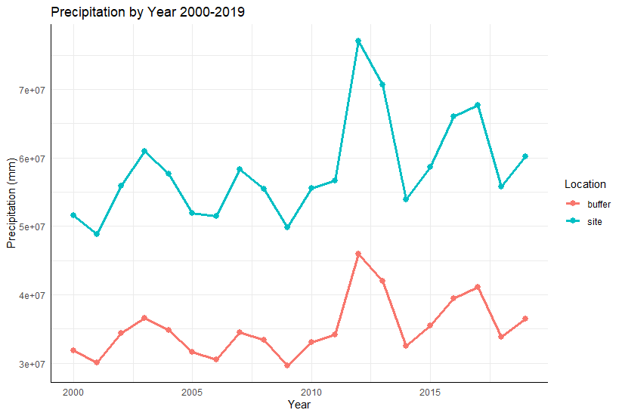

**Figure 12.** This graph shows raw total precipitation for the site and the buffer.

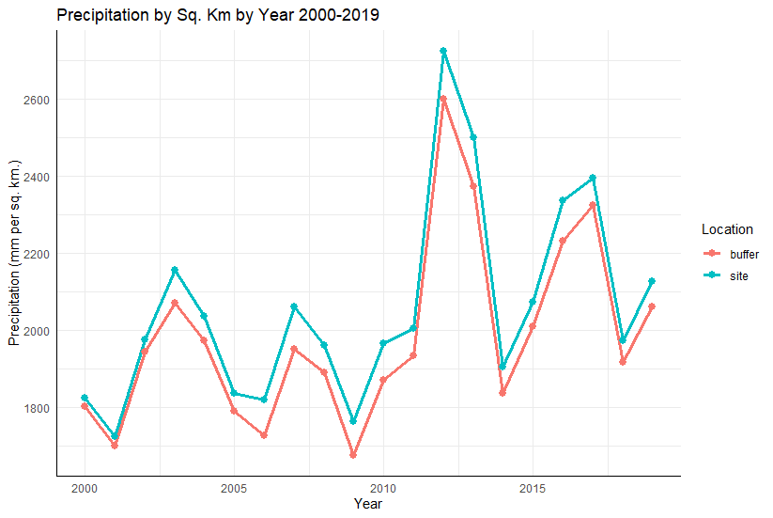

**Figure 13.** This graph shows precipitation normalized by square kilometer. Even with this normalization, there is more rainfall in Parque do Xingu than in the buffer, and significant variability from year to year.

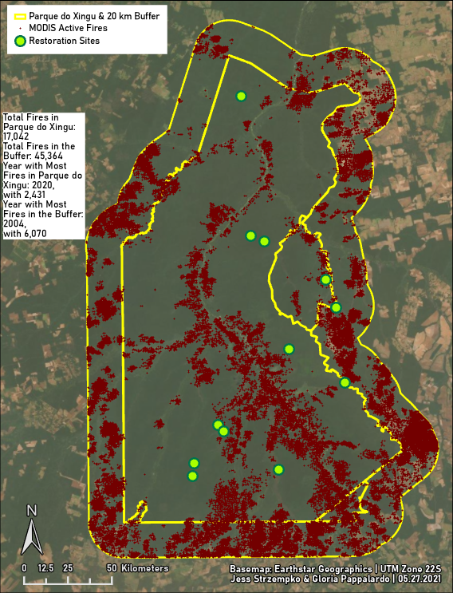

**Figure 14.** Map showing all active fires from 2000-2020 captured by the MODIS satellite in the study area.

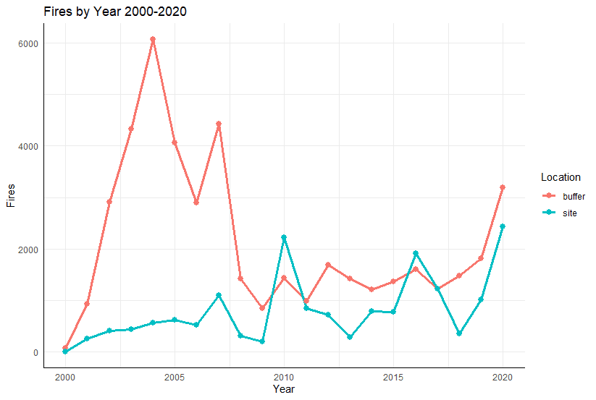

**Figure 15.** The buffer had more fires in the early 2000s, with a peak in 2004 at 6,070 fires, before an overall decline and a small recent increase. An explanation for the increase in site fires is that as forest land in the buffer converted to agriculture, the frontier entered the IPLC and fires grew over time, with a peak in 2020 at 2,431 fires. Still, across the time period there have been 45,364 fires in the buffer to just 17,042 fires in the IPLC itself. This measure is only of active fires according to the MODIS satellite fire product, and is a conservative estimate, as MODIS only registers the hottest fires.

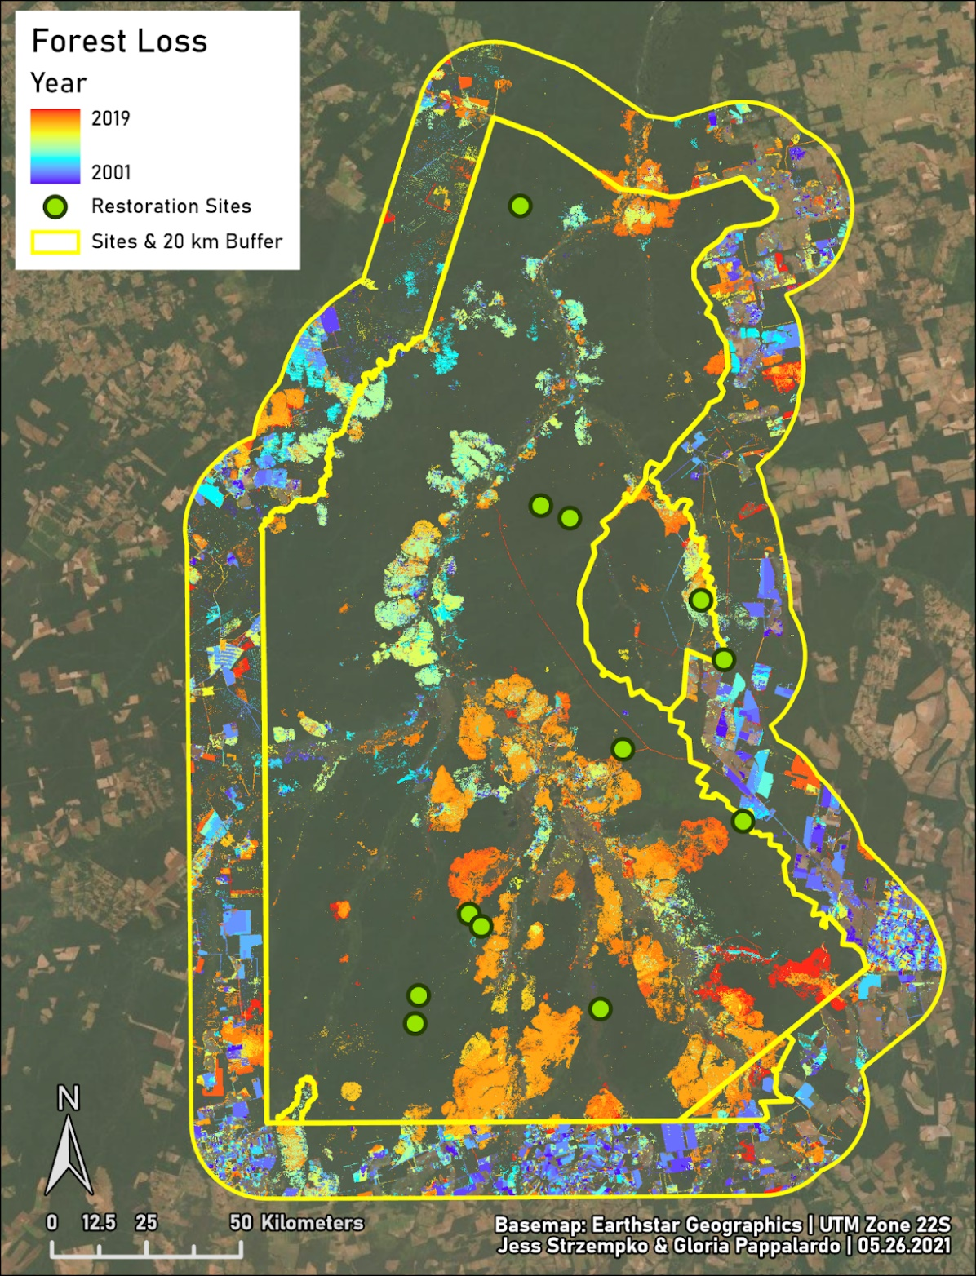

**Figure16.** Forest loss per year from 2000 to 2019 with cooler colors demonstrating loss earlier in the time interval and warmer colors later in the time interval. There is a high amount of forest loss in the buffer in the early 2000s, potentially due to forest clearance for agriculture. The highest amount of forest loss in the site occurs in 2017 and is spatially correlated with fire occurrences.

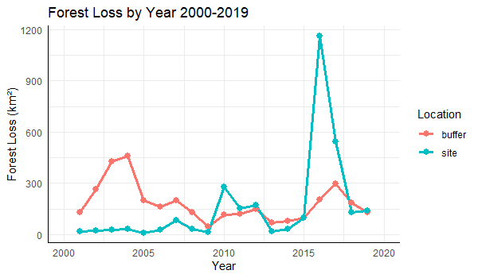

**Figure 17.** Forest loss per year in square kilometers from 2000 to 2019.

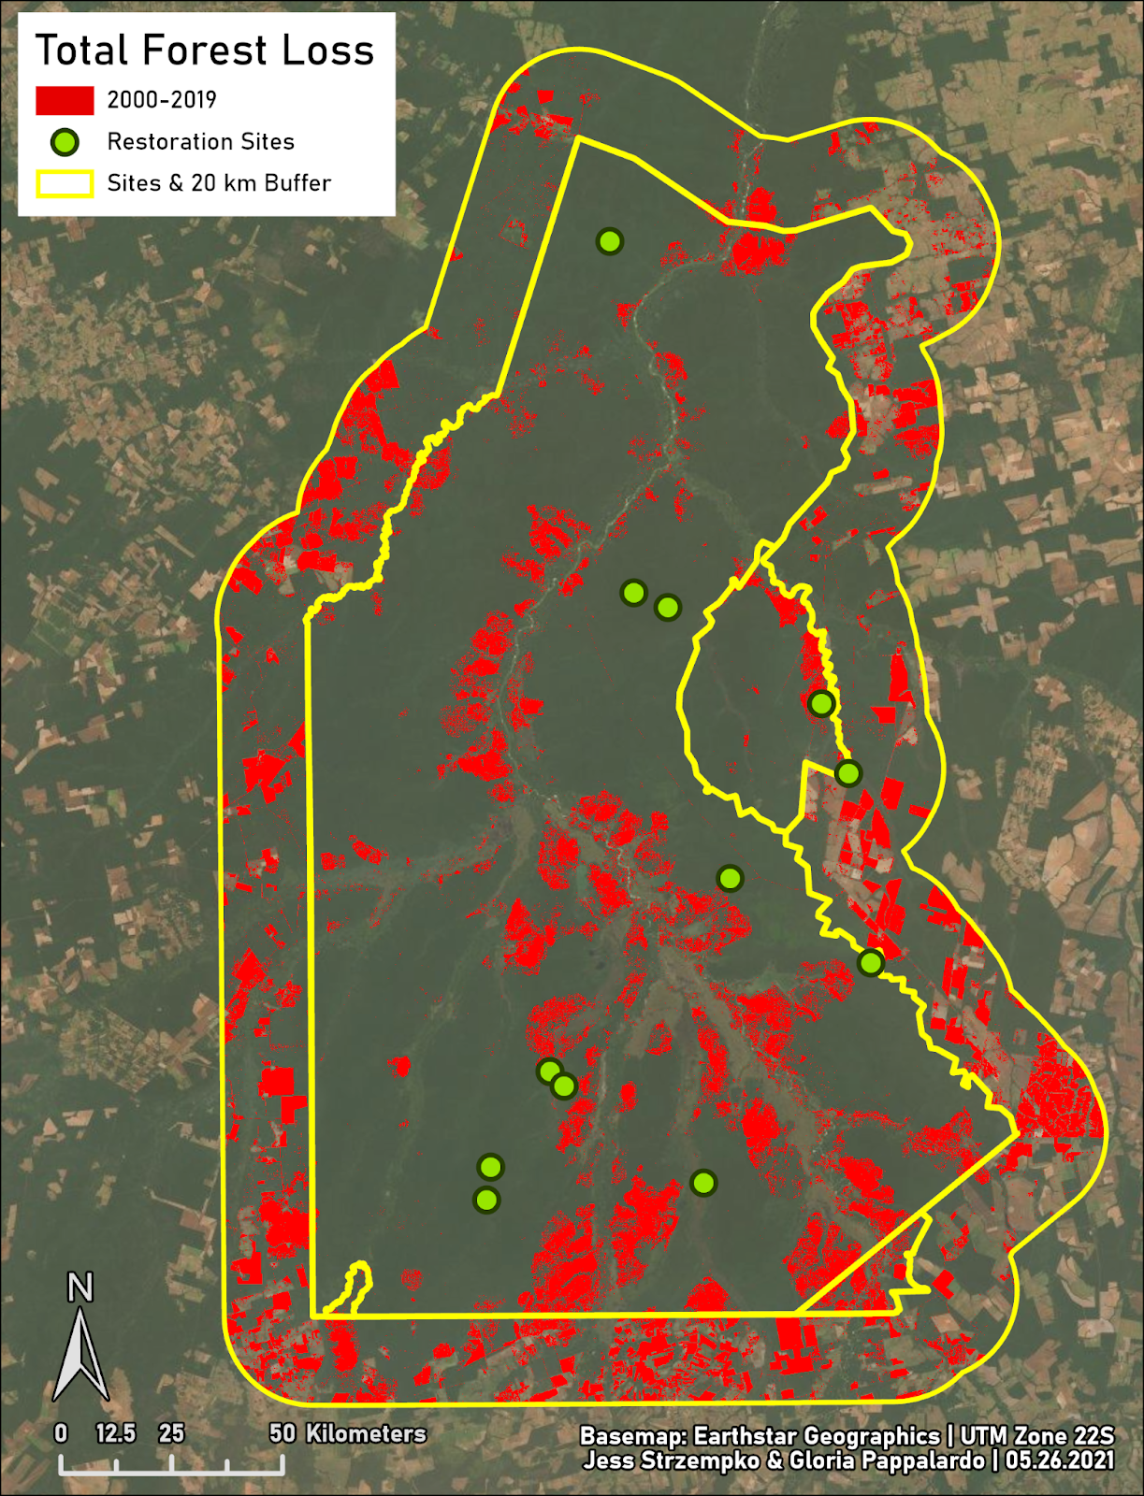

**Figure 18.** Map of total forest loss from 2000 to 2019 in the site and buffer areas. Total forest loss is 6445.14 square kilometers with 2983.01 square kilometers (10.55%) of the site deforested and 3462.13 square kilometers (19.59%) of the buffer deforested.

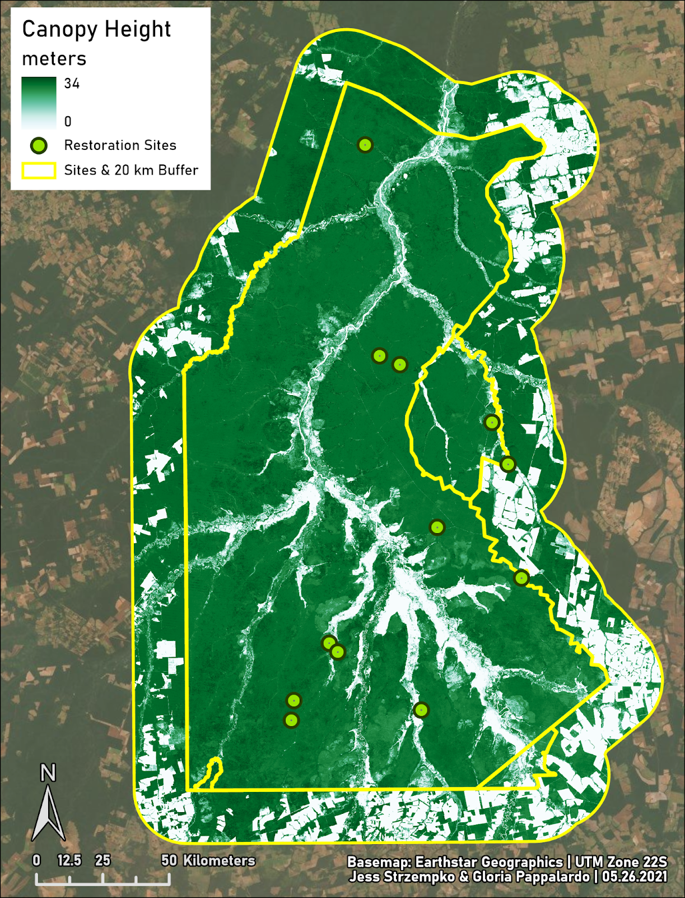

**Figure 19.** Canopy height in meters in the site and buffer areas. Within 100 meters of all restoration sites, the average canopy height is 21.93 meters with a range of 14 to 28 meters.

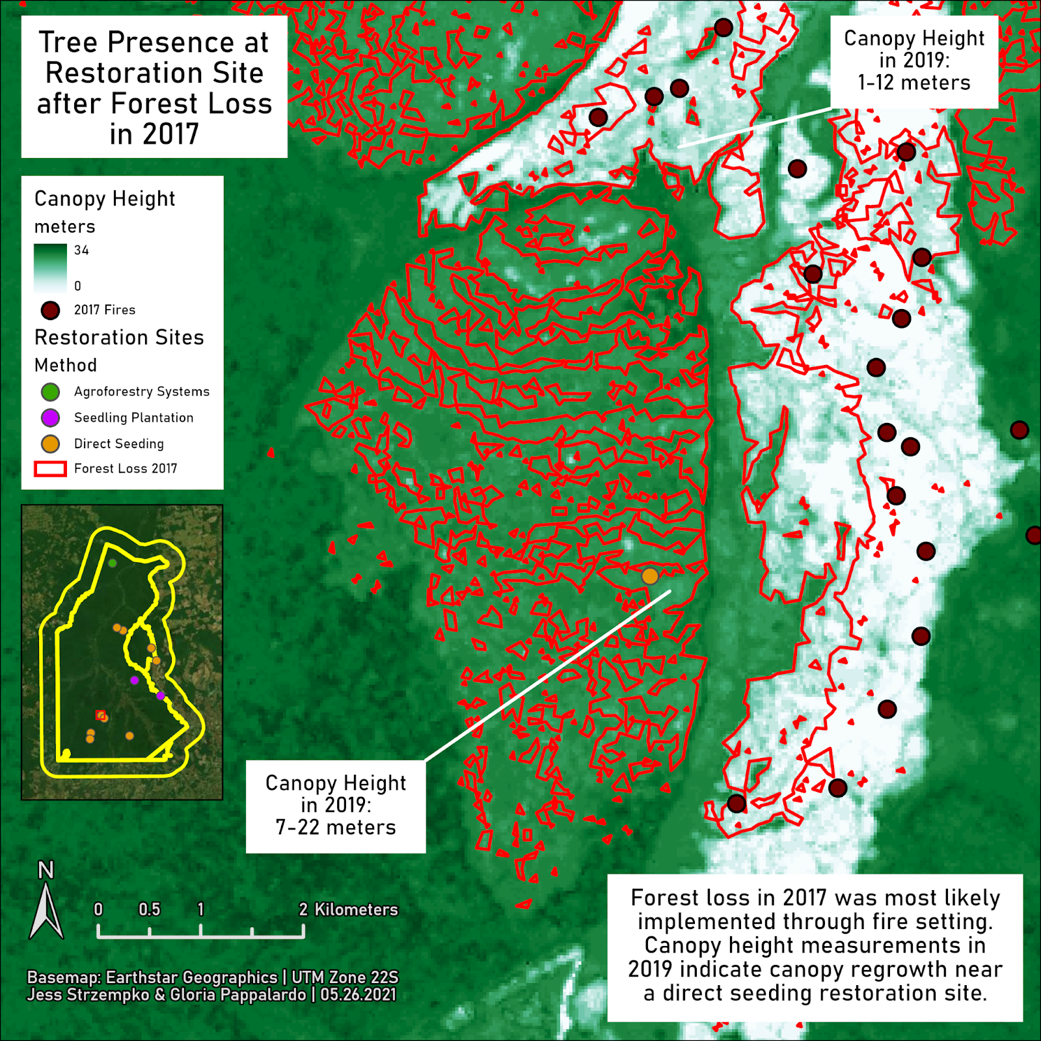

**Figure 20.** Focus area of canopy height in the southern portion of the site. The indication of fire and forest loss in 2017 in conjunction with the presence of a restoration site and canopy height of 7-22 meters in 2019 speaks to potential forest regeneration. Adjacent areas of canopy height 1-12 meters in 2019 possibly demonstrate lack of forest regeneration.

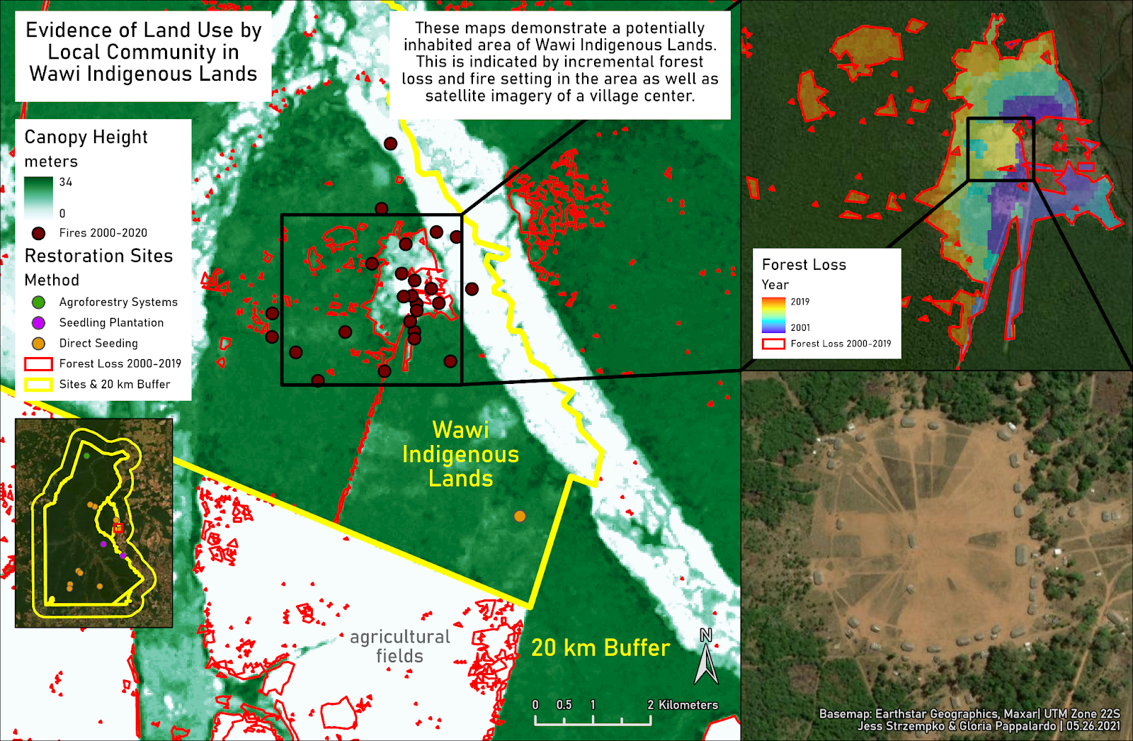

**Figure 21.** Focus area of canopy height in the western portion of the site on Wawi indigenous land. The particular pattern of incremental forest loss and fires potentially indicate sustainable use of the land by the local community that lives in the village shown in the bottom right inset map.

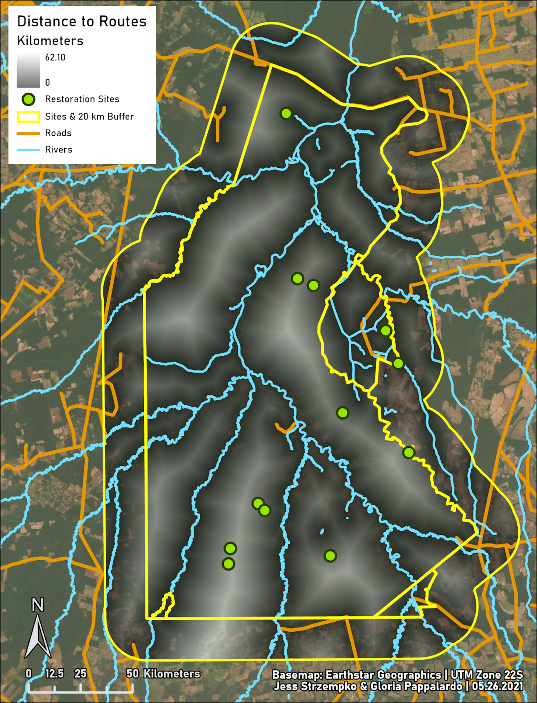

**Figure 22**. Map depicting distance to routes, defined as either rivers or roads to account for travel by land and water.

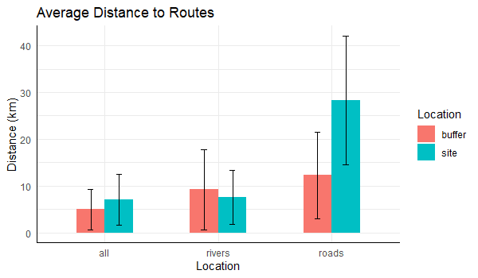

**Figure 23.** Graph of average distance to routes. The buffer is slightly more accessible than the site when considering both rivers and roads as means of transportation. The site is largely accessible by river travel while the buffer is more accessible by road.

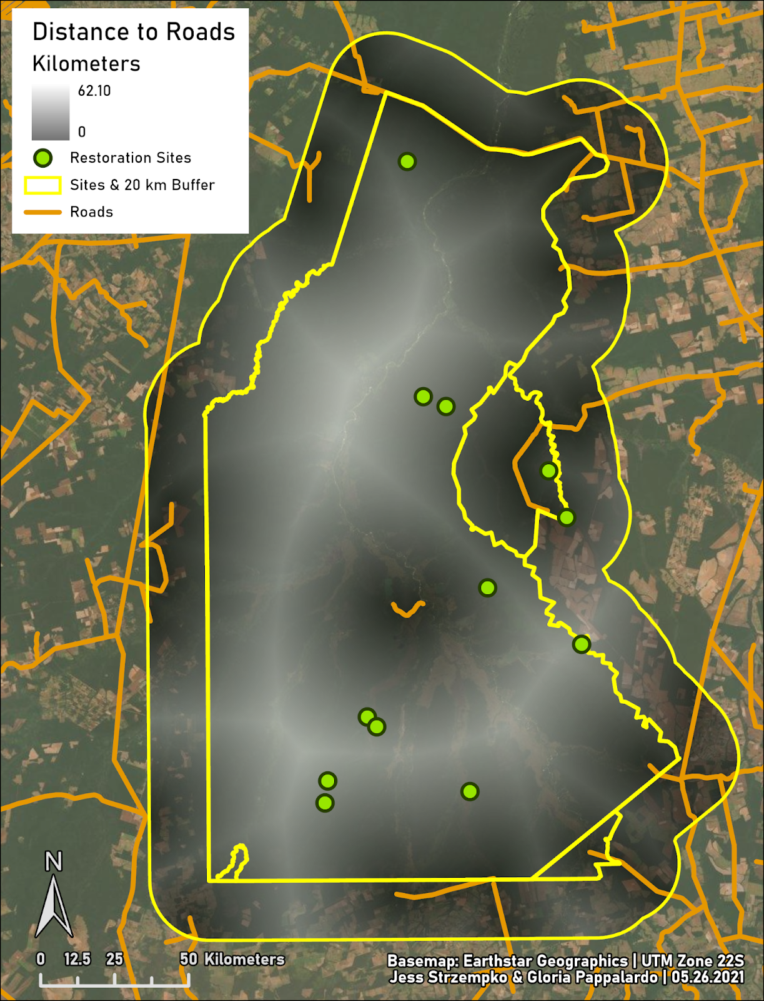

**Figure 24.** Map of distance to roads in the buffer and site.

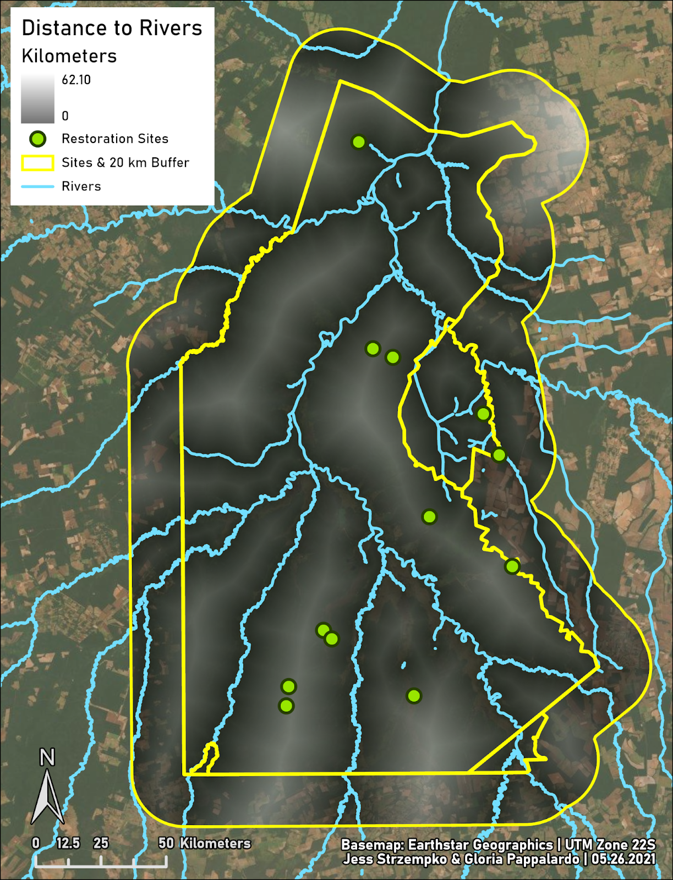

**Figure 25.** Map of distance to rivers in the buffer and site.

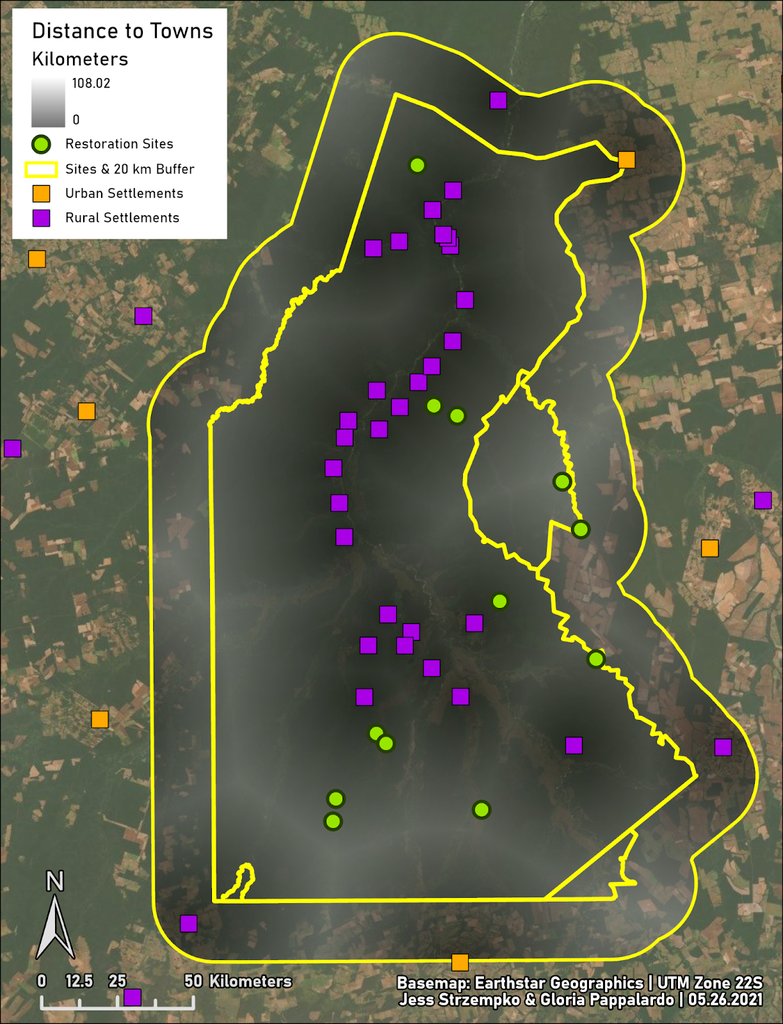

**Figure 26.** Map depicting distance to both urban and rural towns. Many rural towns are found along the Xingu River, though further information is needed to determine if these are indigenous communities or illegal settlements.

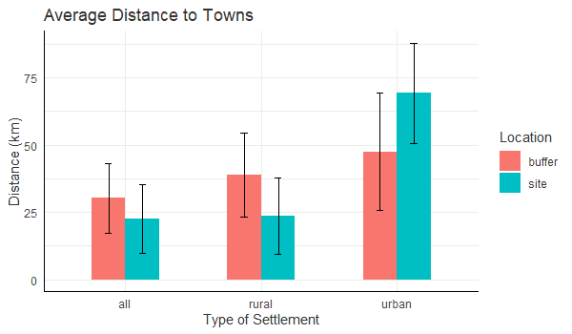

**Figure 27.** Graph of average distance to towns. The site is more accessible than the buffer due to the many rural towns in the site. However, when only considering urban towns, the site is more inaccessible than the buffer.

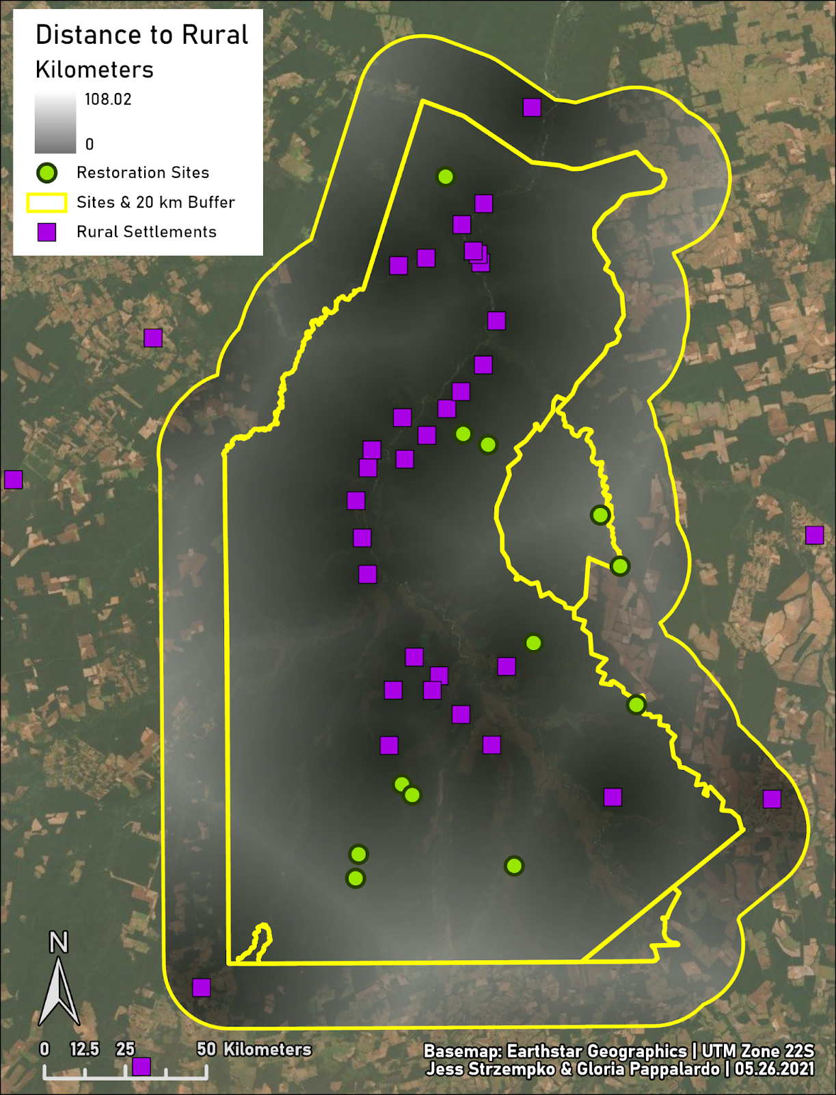

**Figure 28.** Map of distance to rural towns.

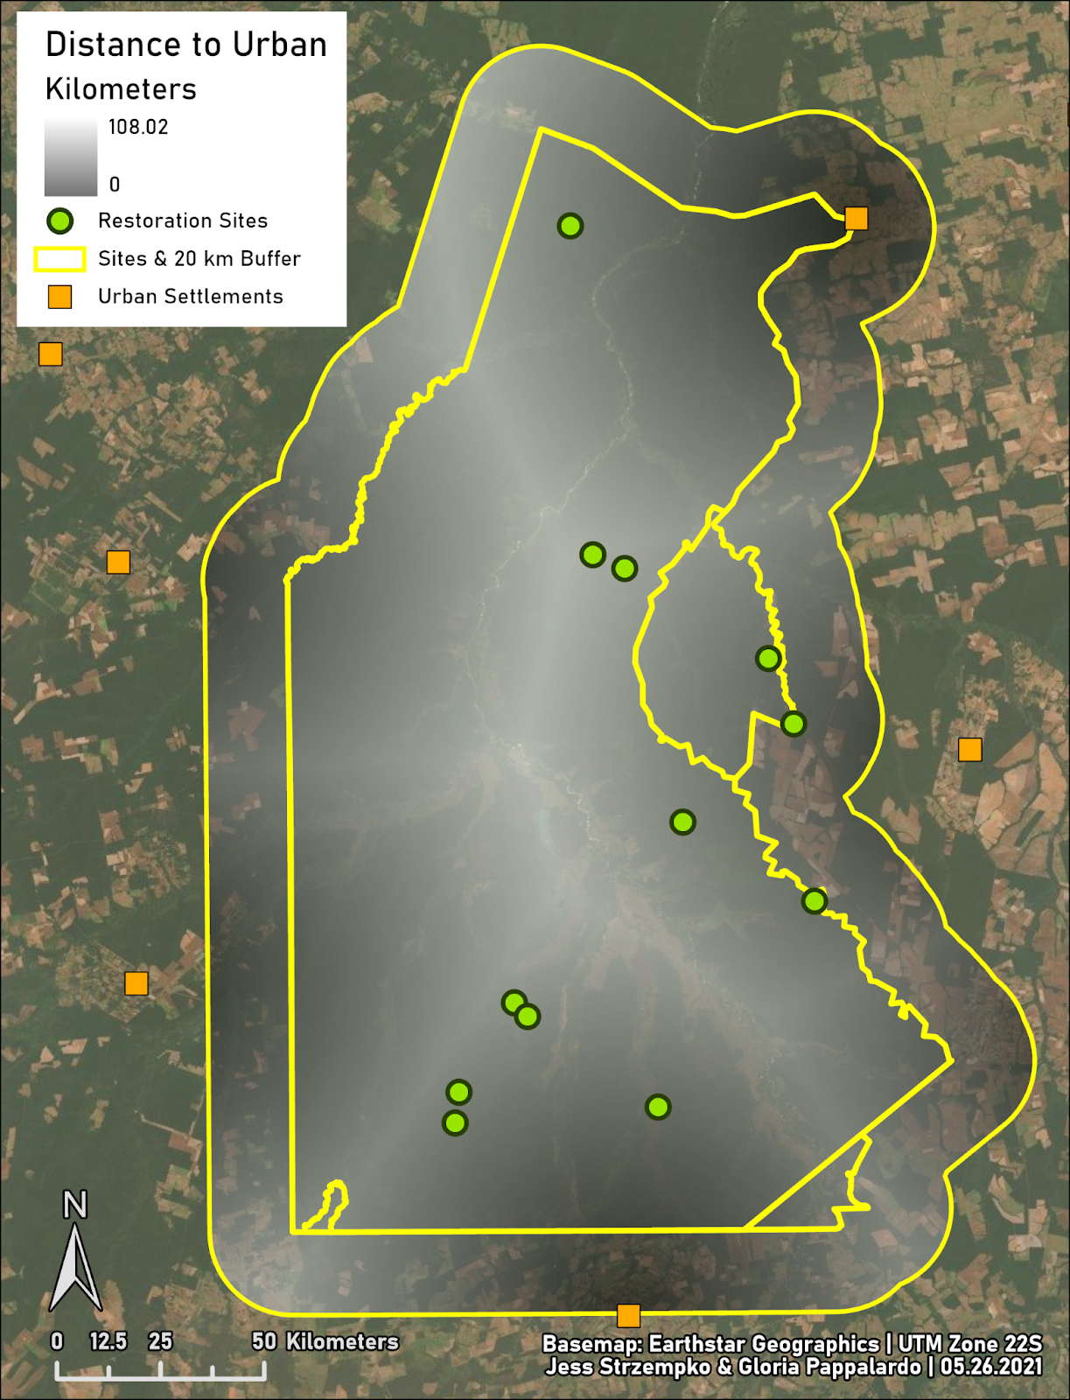

**Figure 29.** Map of distance to urban towns.

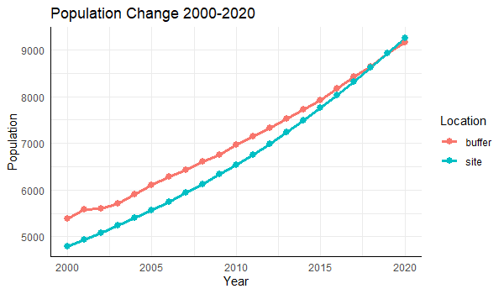

**Figure 30.** Annual sum of population in the site and buffer from 2000 to 2020. The site exhibits a population increase of 92.98%, while the buffer exhibits a 70.29% increase. Note that the population in the site surpasses the population in the in 2020.

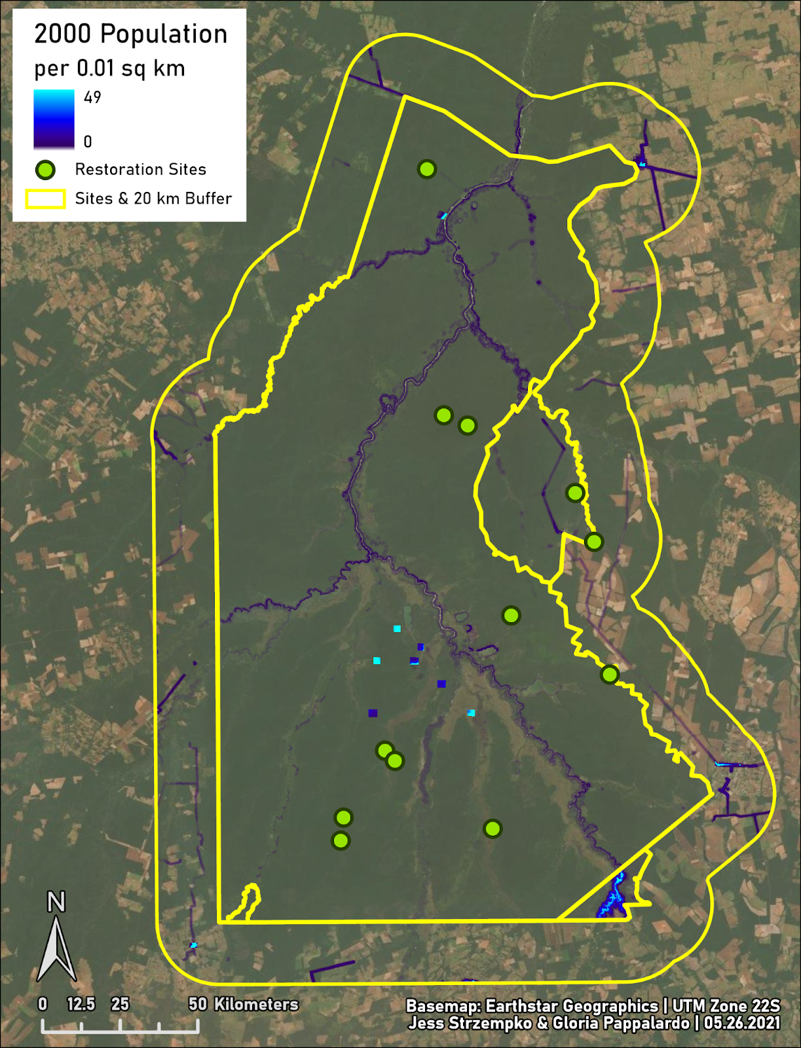**Figure 31.** Static map of population in 2000.

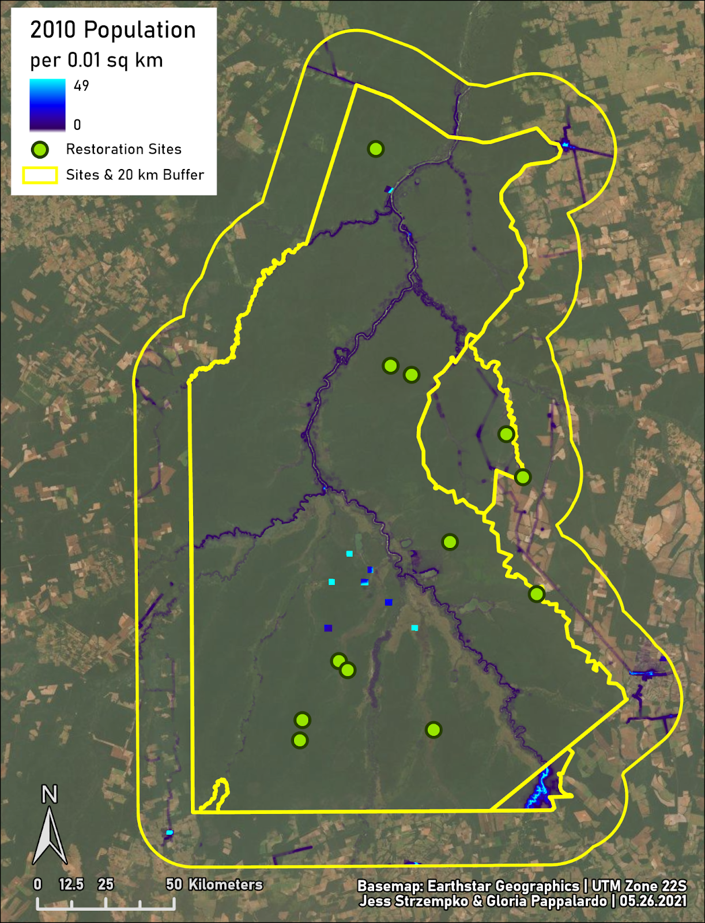

**Figure 32.** Static map of population in 2010.

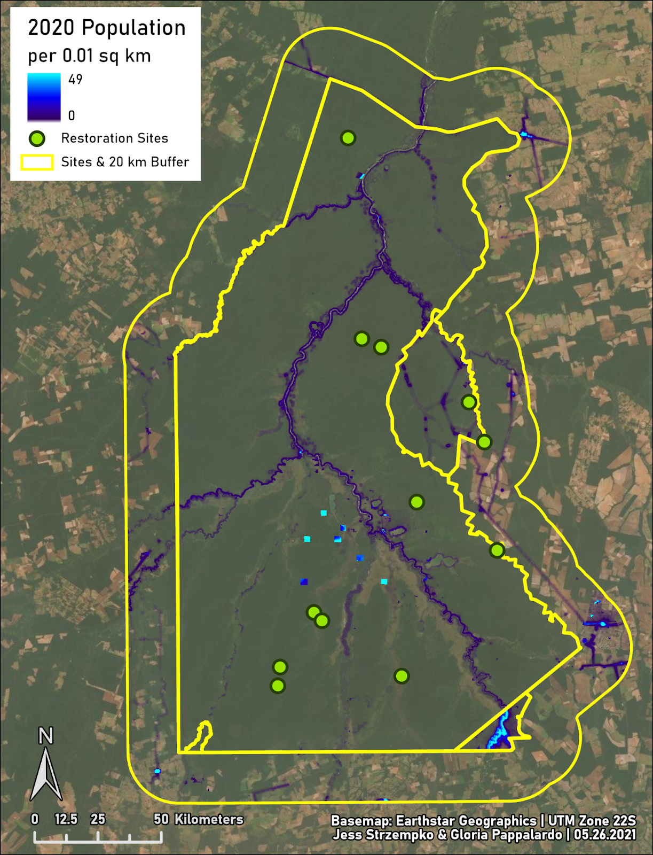

**Figure 33.** Static map of population in 2020. The predominant pattern of change is an increase in population along the Xingu River.

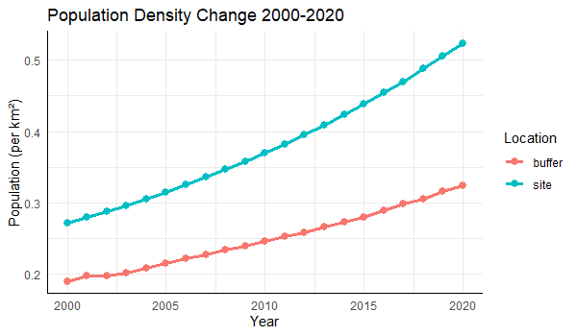

**Figure 34.** Graph of annual population site in the site and the buffer from 2000 to 2020.

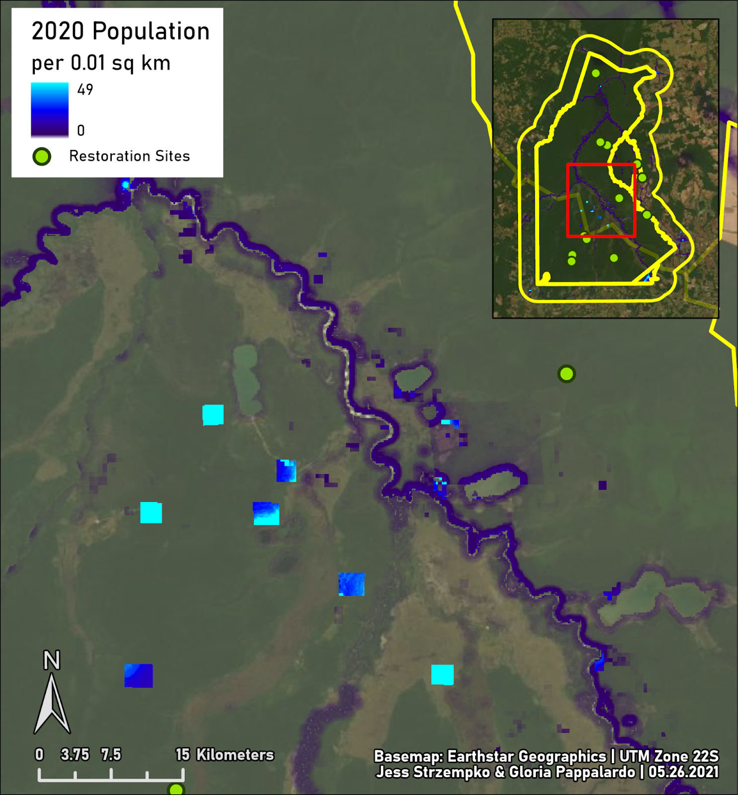

**Figure 35.** Focus area of population in the central region of the site.

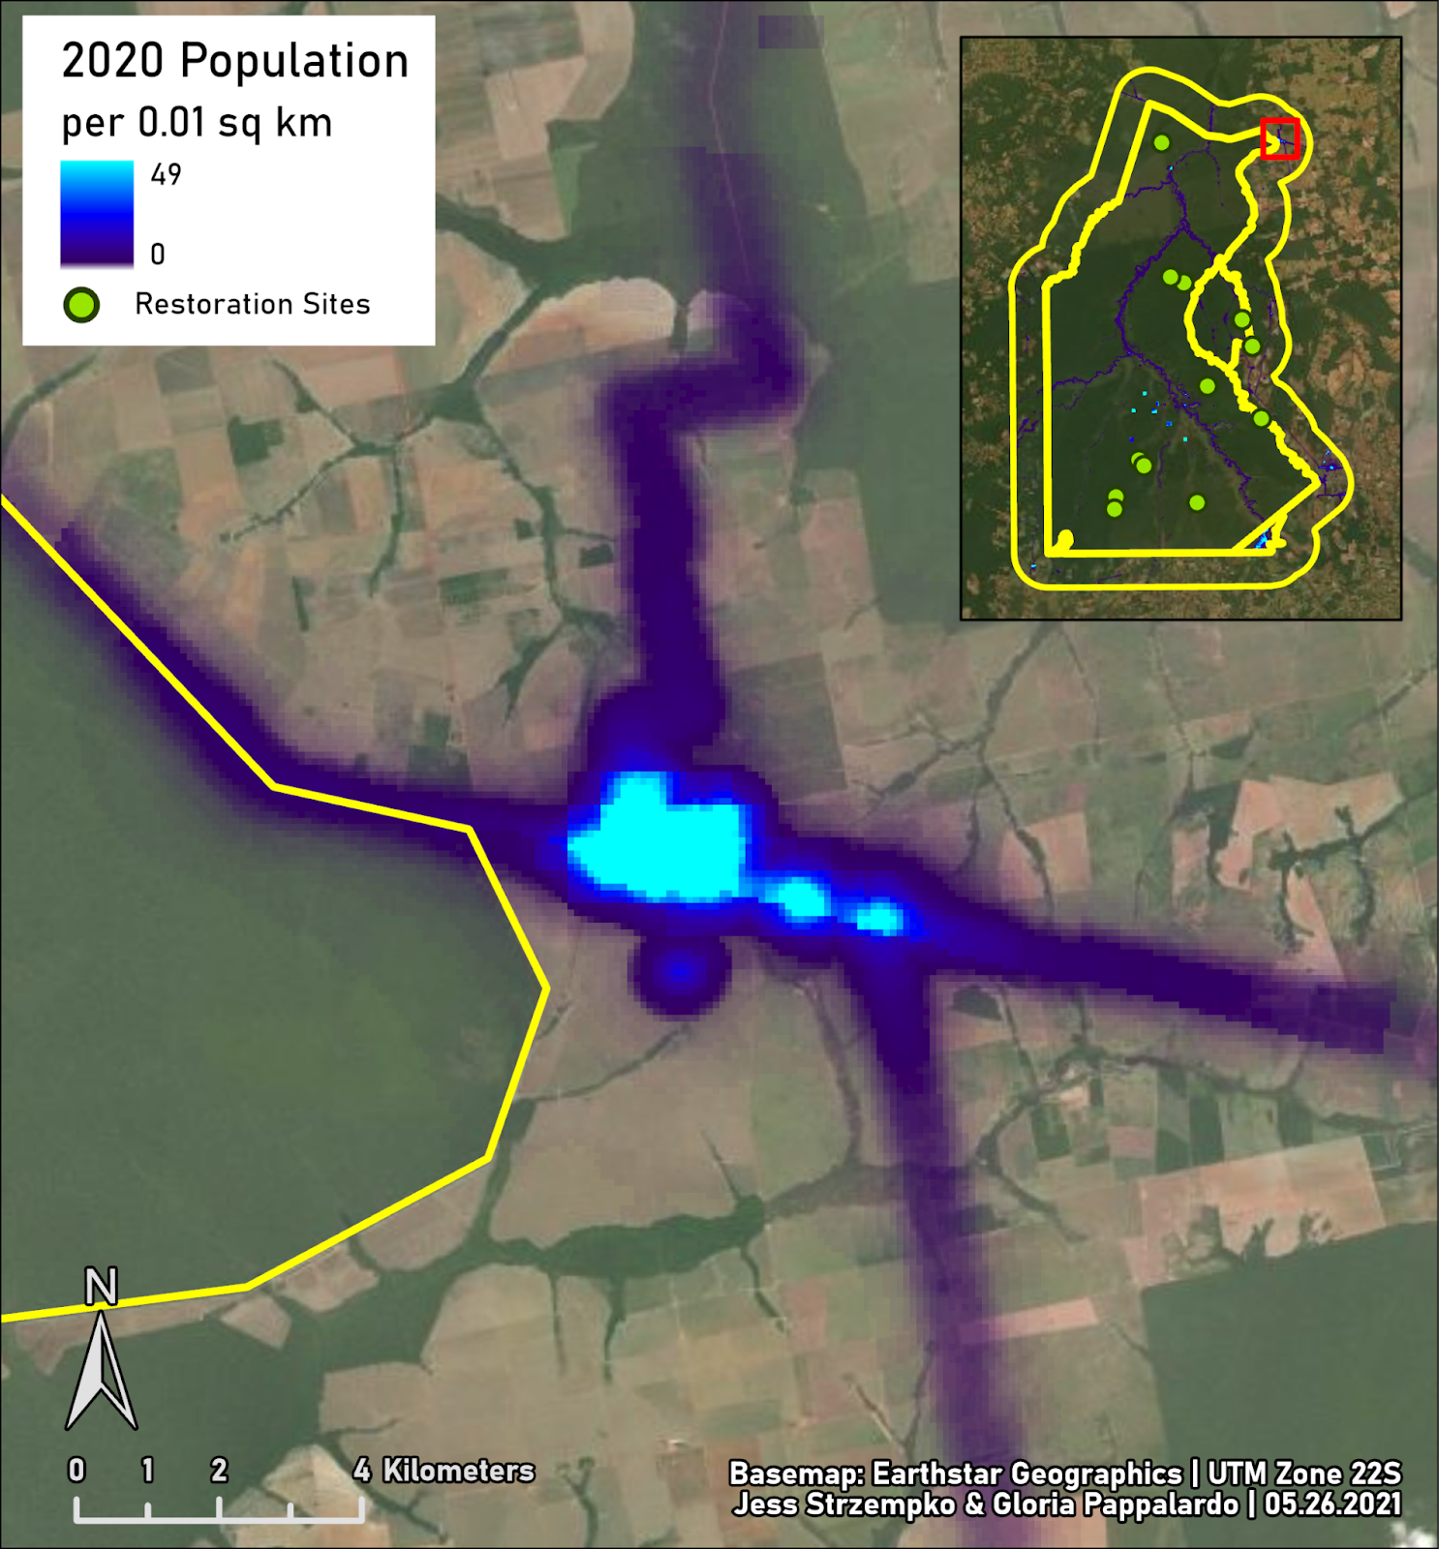

**Figure 36.** Focus area of population in the northern region of the site.

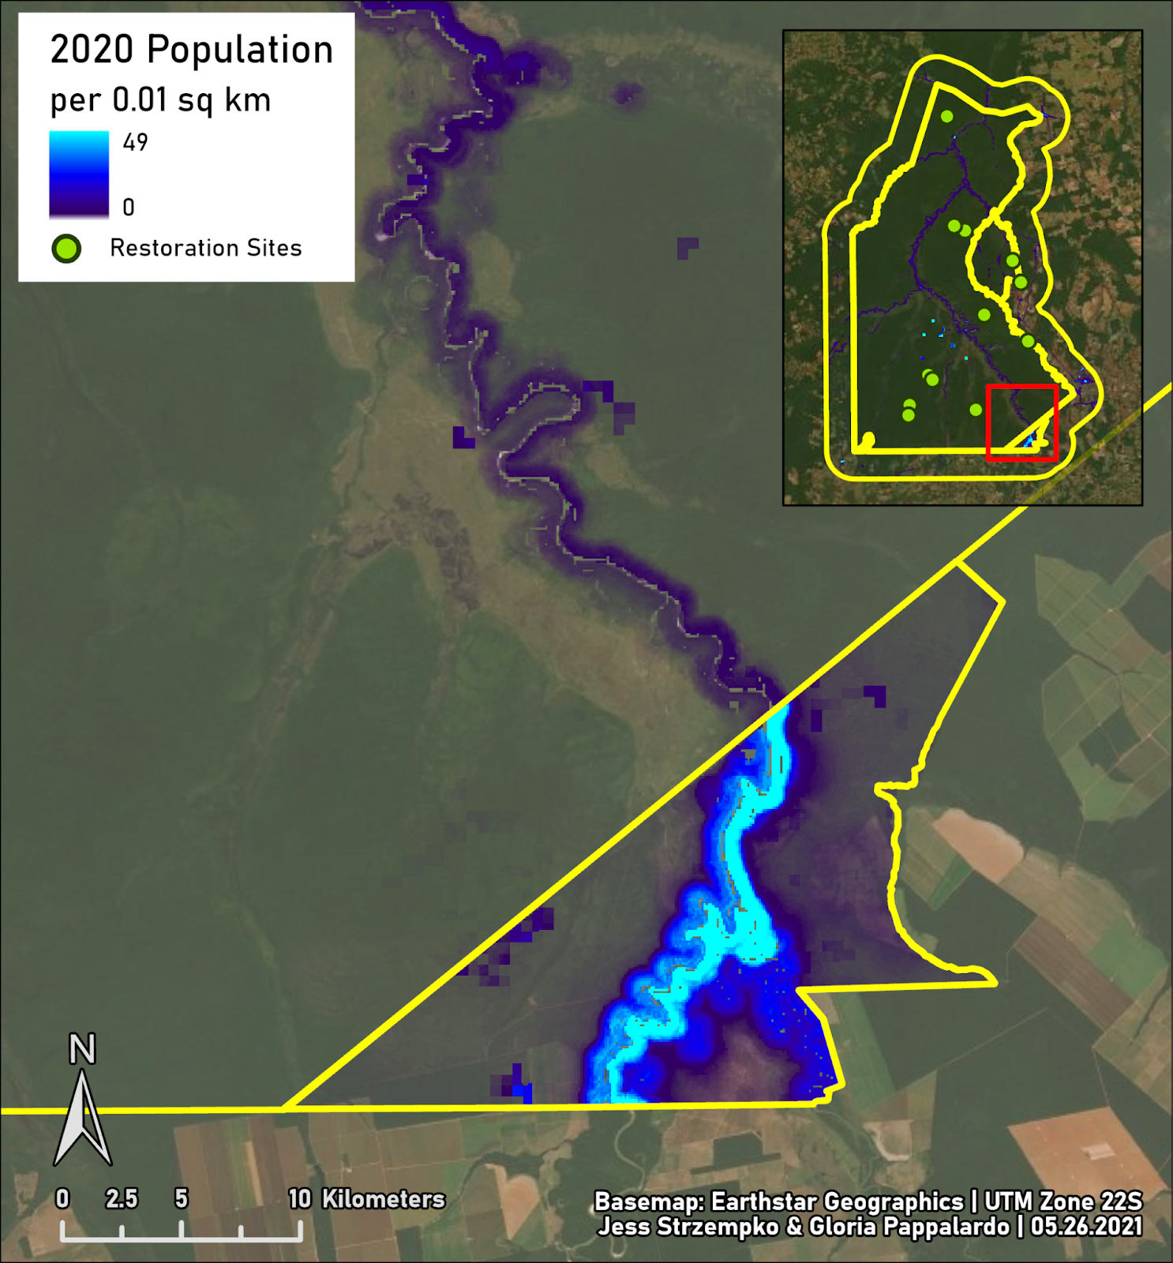

**Figure 37.** Focus area of population in the southern region of the site.

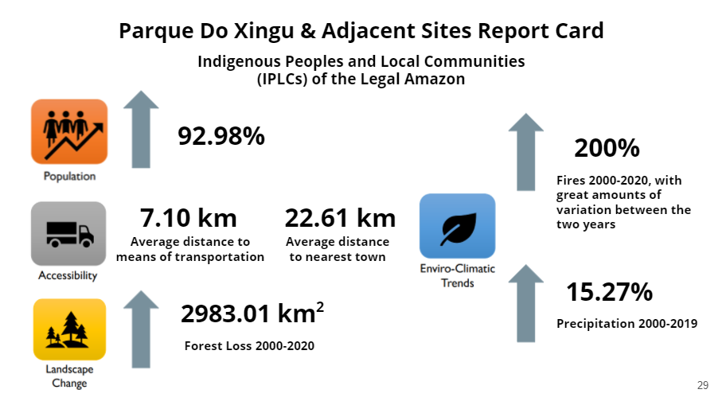

**Figure 38.** Report card summarizing the main statistical results for Parque do Xingu and the adjacent indigenous lands.

Our research and analysis provide an understanding of the environmental and anthropogenic trends in Parque do Xingu during the time interval 2000 to 2020. Population within the site has increased substantially by 92.98%, potentially due to the migration of outside populations into IPLC land. Despite natural variations in fire conditions, fire occurrences have increased over the study interval indicating intentional fire setting. We observe a correlation between fire and forest loss events in location and timing. From 2000 to 2020, 2,983.01 km2 of forest cover was deforested with a large swath of loss in 2017 along the Xingu River.

Encouraging signs of forest regeneration are present in the vicinity of a previously deforested restoration site. On the other hand, the increase in deforestation and fire in the site provides a sobering portrait of a land in contention for its natural resources. As is the story in many other parts of the Legal Amazon, economic pressures and a growing population tend to go hand in hand with natural resource exploitation. A more detailed analysis of the situation in Parque do Xingu and adjacent indigenous lands would be necessary to determine the socioeconomic forces at work on the surrounding population and the indigenous communities.

Our results demonstrate anthropogenic impact on Parque do Xingu and the adjacent sites through population gains, forest loss, and fire occurrences. The difference in results between the site and the 20-kilometer buffer zone is logically consistent with the historical context of the indigenous lands and the political forces at play in Brazil within the past two decades. Decreased development and forest loss within the buffer over the study interval is most likely a result of dwindling natural resources from decades of land conversion for agriculture. Increased development and forest loss within the site over the study interval may be a result of looser environmental protections from the Mato Grosso or Brazilian governments, but further research would be necessary to understand the specifics of this important topic.

Discussion

Our results demonstrate the spatiotemporal distribution of socio-environmental factors within and around Parque do Xingu and the adjacent indigenous lands. We produced descriptive and statistical information on the variables of interest within the chosen site and counterfactual buffer zones. Our project goals center around understanding the impact of IPLC land titling on conservation in the study area. Due to the varied history of land titling in the Parque do Xingu, Wawi, Batovi, and Pequizal do Naruvôtu indigenous lands, our incorporation of land titling information into the analysis is to provide context for interpretation. With land titles established in 1961, 1998, and 2016, the study area offers the opportunity to examine early- and late-establishment IPLC sites. Furthermore, our inclusion of restoration sites throughout the analysis allows us to generalize the conditions of forest restoration sites while raising further questions regarding how these site locations were chosen and how they operate.

Lastly, we provide the data necessary to perform a further analysis of the variables to determine statistical significance between the site and counterfactual buffer zone. The data gathered on accessibility measures, landscape change, population growth and enviro-climatic trends provide a proof of concept to CI of how to source, process, and interpret spatial data to prove, and improve, the efficacy of conservation work in the Legal Amazon.

References

Blackman, A. (2013). Evaluating forest conservation policies in developing countries using remote sensing data: An introduction and practical guide, *Forest Policy and Economics*, *34*, 1-16, <https://doi.org/10.1016/j.forpol.2013.04.006>

Cabral, A. I., Saito, C., Pereira, H., & Laques, A. E. (2018). Deforestation pattern dynamics in protected areas of the Brazilian Legal Amazon using remote sensing data. *Applied Geography*, *100*, 101-115. <https://doi.org/10.1016/j.apgeog.2018.10.003>

Ferraro, P. J. (2009). Counterfactual thinking and impact evaluation in environmental policy. *New directions for evaluation*, *2009*(122), 75-84. <https://doi.org/10.1002/ev.297>

Ferraro, P.J. and Hanauer, M.M. (2014). Advances in measuring the environmental and social impacts of environmental programs. *Annual review of environment and resources*, *39*, 495-517. <https://doi.org/10.1146/annurev-environ-101813-013230>

Giglio, L., Schroeder, W., and Justice, C. (2016). The collection 6 MODIS active fire detection algorithm and fire products. *Remote Sensing of Environment*, 178, 31-41. <https://doi.org/10.1016/j.rse.2016.02.054>

Griscom, B.W., Adams, J., Ellis, P.W., Houghton, R.A., Lomax, G., Miteva, D.A., Schlesinger, W.H., Shoch, D., Siikamäki, J.V., Smith, P. and Woodbury, P. (2017). Natural climate solutions. *Proceedings of the National Academy of Sciences*, *114*(44), pp.11645-11650. <https://doi.org/10.1073/pnas.1710465114>

Instituto Socioambiental. (2021). *Terras Indígenas no Brasil*. Terra Indígenas. <https://terrasindigenas.org.br/>

Menezes, M.L.P. (2009). Parque Indígena do Xingu: efeitos do modo de vida urbano e da urbanização no território indígena. *Novos Cadernos NAEA*, *11*(2). <http://dx.doi.org/10.5801/ncn.v11i2.278>

Ostrom, E. (1990). *Governing the commons: The evolution of institutions for collective action*. Cambridge university press.

Pfaff, A., Robalino, J., Walker, R., Aldrich, S., Caldas, M., Reis, E., Perz, S., Bohrer, C., Arima, E., Laurance, W. and Kirby, K. (2007). Road investments, spatial spillovers, and deforestation in the Brazilian Amazon. *Journal of regional Science*, *47*(1), 109-123. <https://doi.org/10.1111/j.1467-9787.2007.00502.x>

Plant, R., & Hvalkof, S. (2001). *Land titling and indigenous peoples* (No. 39218). Washington, DC: Inter-American Development Bank.

Strahler, A.H., Woodcock, C.E. and Smith, J.A. (1986). On the nature of models in remote sensing. *Remote sensing of environment*, *20*(2), pp.121-139. <https://doi.org/10.1016/0034-4257(86)90018-0>